N Azure Virtual Networks and Virtual Machines

2. Write an ARM Template to deploy a windows VM using the existing VNets and NSGs.

Step 1: Go to azure portal and click on a create a new resource.

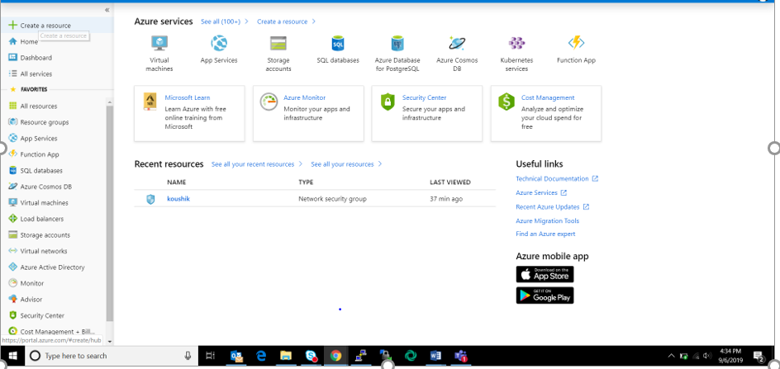Step 2: Search for “template deployment” in the marketplace. 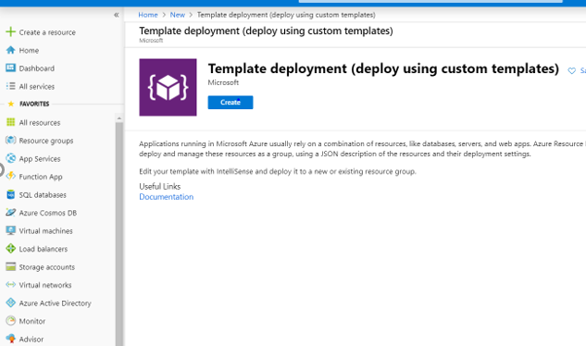

Step 3: Click on create and select the “Build your own template in editor” option and paste the arm template.

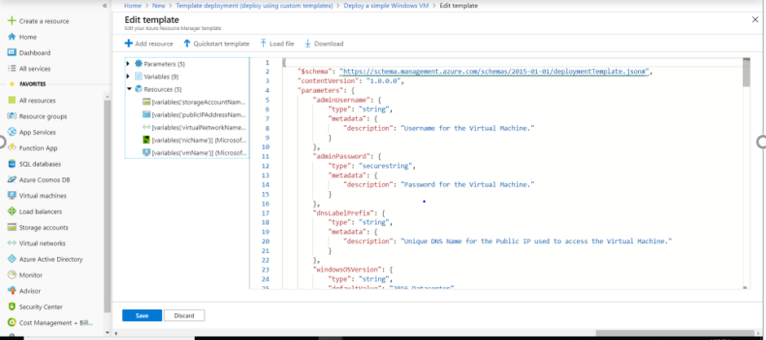

Step 4: Click on save and enter details and click on purchase.

Step 5: We will get a message that the deployment is complete. Now, the VM can be accessed using the username and password given during the configuration.